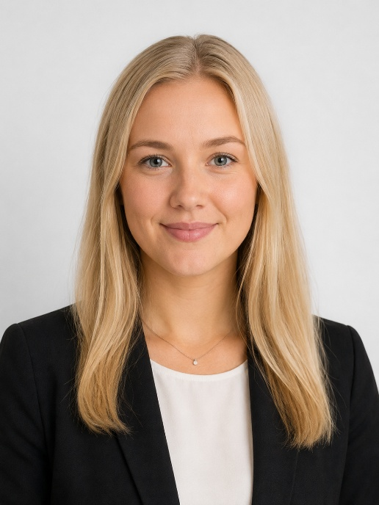 | ELENA  VIRTANEN  PEOPLE & STRATEGY LEADER
CONTACT  🌐 elena-virtanen.fi  🔗 linkedin.com/in/elena’-virtanen  ✉ elena.v’’’’’’@outlook.com  📍 Espoo, Finland  ☎ +358 41 771 2293  EDUCATION  - Master of Science (M.Sc.), Business Administration  (Strategy and Leadership)  Aalto University School of Business, 2021  - Bachelor of Science (B.Sc.), Economics  (International Business)  University of Turku, 2009  TRAININGS  - Executive Leadership Program (Kone-Spencer Stuart)  - Prosci Change Management Certification  - Multiple internal trainings in strategy, organizational design, and people leadership  - Design Thinking Practitioner, IDEO  - Executive coaching (ICF accredited)  TECHNICAL SKILLS  - OKRs & balanced scorecard  - Data & people analytics  - MS Office 365 (expert level)  - HRIS systems (Workday, SAP SuccessFactors)  - Power BI & data visualization  - AI tools & prompt engineering  - Survey & feedback platforms  - Agile & OD methodologies  - Organizational design frameworks  - Facilitation & workshop design  - Currently deepening expertise in AI-driven HR transformation and organizational analytics  LANGUAGES  - Finnish (Native)  - English (Fluent)  - Swedish (Professional), German (Elementary) | EXECUTIVE SUMMARY  People & Organizational Strategy | Culture Transformation | Leadership Development | HR Excellence  Strategic, empathetic, and results-oriented-focused leader with over 15 years of experience in people strategy, organizational development, culture transformation, and HR-driven transformation. I specialize in creating the conditions where people and organizations can perform at their best.  I am deeply passionate about the future of work and the role of AI‑in reshaping organizations. I actively explore how emerging technologies can elevate people practices, decision‑making, and the overall employee experience.  My work sits at the intersection of people, culture, and business performance. I have built leadership development programs, redesigned talent and performance frameworks, and delivered measurable improvements in engagement, retention, and organizational capability. I thrive in environments requiring cultural renewal, bold thinking, and human-centered change.  LEADERSHIP PHILOSOPHY  I believe organizations flourish when people feel seen, trusted, and challenged to grow. Culture is not a by-product of strategy — it is the strategy. My leadership philosophy is built on three principles:  - Build psychological safety: people do their best work when they feel safe to speak, try, and fail.  - Design for growth: structures, roles, and development paths that stretch people beyond their comfort zones.  - Model the culture: values are lived through everyday decisions, not written on walls.  CORE COMPETENCIES  KEY ACHIEVEMENTS  - Designed and launched a company-wide talent review and succession framework covering 450+ employees across four business units.  - Built and delivered a flagship leadership development program for ~180 managers, achieving a participant satisfaction score of 4.5/5 and measurable improvement in 360 feedback results.  - Led a culture transformation initiative following a major merger, reducing voluntary turnover by 22% within 18 months and improving eNPS from +12 to +41.  - Redesigned the performance management framework, shifting from annual reviews to continuous feedback cycles, adopted by 95% of the organization within one year.  - Implemented a new HRIS platform (Workday) across six countries, consolidating four legacy systems and reducing HR administration time by 35%.  - Established a Group-level DEI strategy and governance model, resulting in a 30% increase in female leadership representation over three years.  PROFESSIONAL EXPERIENCE  Kone Corporation – VP, People & Culture | Mar 2021–Present  - Member of the Group HR Leadership Team, contributing to enterprise-wide people strategy.  - Lead people strategy and HR business partnering for three global divisions with combined headcount of 3,200.  - Driving AI-in-HR transformation agenda, piloting AI tools in talent acquisition, performance, and workforce planning.  - Improved employee engagement scores by 18 percentage points over three years.  - Designed and scaled a global leadership development curriculum reaching 300+ leaders annually.  - Developed people processes and practices aligned with Group governance and compliance standards.  - Facilitated executive team effectiveness and organizational alignment workshops.  - Strengthened HR governance, decision-making structures, and HR performance reporting.  - Broad HR scope including talent management, compensation review, workforce planning, employee relations, wellbeing, internal communications, employer branding, and HRIS development across divisions and Group.  Kone Corporation – HR Business Partner, Technology | Jan 2019 – Feb 2021  - Led HR transformation program to align people processes, governance structures, and management systems with Group standards across newly acquired entities.  - Acted as strategic HR business partner to C-suite stakeholders, aligning people initiatives with business objectives and organizational priorities.  - Built people analytics capability from the ground up, enabling data-driven talent decisions and board-level workforce reporting.  - Supported post-merger organizational integration, including harmonization of job architecture, grading, and compensation frameworks.  Wärtsilä – HR Director, Operations | 2013–2017  - Led HR for the global Operations division (2,800 employees across 12 countries), partnering with divisional leadership on talent, culture, and organizational effectiveness.  - Designed and implemented a structured talent review process and succession pipeline for critical operational roles.  - Directed end-to-end recruitment transformation, reducing time-to-hire by 40% and improving quality-of-hire metrics.  - Led a division-wide culture survey and action planning cycle, resulting in targeted capability programs and structural changes.  - Developed global HR policies, job architecture, and grading structures to support organizational scalability.  - Partnered with business leaders on organizational design, restructuring, and workforce transitions in 6 countries.  - Strengthened HR data quality and built operational people dashboards for senior leadership decision-making.  - Defined a three-year HR strategic roadmap aligned with the divisional business transformation agenda.  Metso – HR Manager, Finland | 2009–2013  - Led HR operations for Finnish business units (800+ employees), covering the full employee lifecycle from onboarding to offboarding.  - Managed annual compensation review and salary benchmarking process for 800 employees.  - Drove process improvements in HR administration, reducing manual work through system automation.  - Led and developed a team of four HR advisors and coordinators across two sites.  - Partnered with union representatives on collective agreement negotiations and employee relations matters.  Metso – HR Coordinator (Trainee) | 2007–2009  - Supported HR generalist activities across recruitment, onboarding, and employee administration. First exposure to HR analytics and reporting.
  People & Organizational Leadership  - People strategy  - Organizational design  - Talent management  - Succession planning  - Performance frameworks  - HR operating models  - Leadership team  development  - Executive coaching | Change Leadership & People Development  - Coaching & mentoring  - Change management (Prosci)  - Learning & development  - Leadership programs  - Culture transformation  - Facilitation & co-design  - DEI strategy & inclusion  - Wellbeing & resilience | Business, Process & Technology Development  - HR analytics  - People process design  - HRIS implementation  - Workday & SuccessFactors  - Survey & listening tools  - Data governance  - GDPR & HR compliance  - Policy & framework design  - AI in HR transformation  - Agile HR

